# **2. Literature review**

2.1. Parechinus angulosus

The Cape sea urchin, *Parechinus angulosus*, is endemic to southern Africa and belongs to the Parechinidae family. It is widely distributed around the Cape Peninsula from Lüderitz, Namibia in the North to Umhlali, Kwa-Zulu Natal, South Africa in the South (Fricke, 1980). The Cape Peninsula is region with a strong seawater temperature gradient (*temperature range), due to the overlap of the Benguela (South African west coast) and Agulhas (South African south coast) currents, and high species diversity, due to the co-occurrence of species from both marine provinces (Leliaert et al., 2000). The region of overlap has been designated the ‘Western Overlap’ in the literature and is characterized by kelp beds created by *Ecklonia maxima* (to depths of 8m) and *Laminaria pallida* (predominantly from 8-14m and up to 20m depths) wherever there are rocky substrata in the shallow subtidal (Leliaert et al., 2000). The distribution of the Cape urchin is closely associated with the southern African kelp beds which characterize its habitat.

The Cape urchin is an important grazer in the southern African kelp bed ecosystem (Greenwood, 1980) where it feeds exclusively on algae, primarily *Ecklonia maxima* (Fricke, 1979). The Cape urchin regulates kelp density by grazing on the young sporophytes and kelp debris (Fricke, 1979). Cape urchins can climb up and actively graze on the kelp stipes under calm conditions (Fricke, 1979; Morris & Blamey, 2018). However, this behavior is uncommon due to the generally turbulent sea conditions, which produce kelp detritus and provide an ample supply of organic matter for the urchins which reduces the likelihood of active grazing (Fricke, 1979). (bulk up a bit more)

In contrast to urchins from kelp bed ecosystems in other regions, e.g. *Stronglyocentrotus spp.* in the northern hemisphere*,* the Cape urchin does not sever kelp stipes or form feeding fronts which decimate kelp populations to the point of a regime shift from an algal-dominated ecosystem to an urchin-dominated alternative stable state known as an “urchin barren”(Anderson et al., 1997). Sea urchin barrens have much lower primary productivity and habitat structural complexity, threatening the health of kelp bed ecosystems (Filbee-Dexter & Scheibling, 2014). Sea urchins have a reputation for destruction in some regions however, they have an important role within marine ecosystems. (*discuss why urchins are important, what role do they play?)

(*What don’t we know about this species?)

(*Why is this species worth studying?)

(*Does this species have any value?)

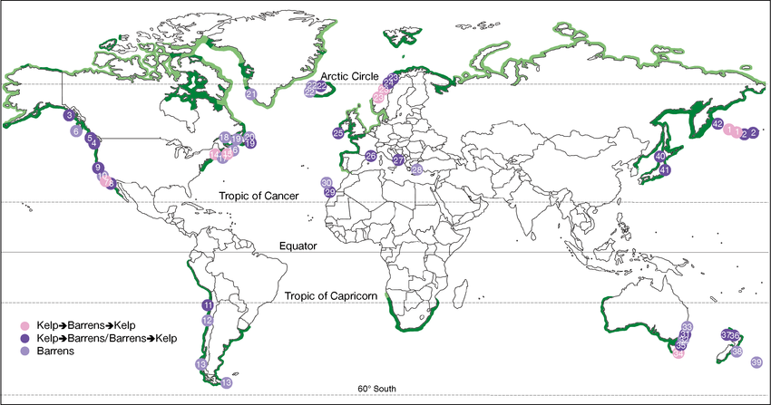

Figure 1 [adapted from Filbee-Dexter & Scheibling (2014)]: A map of the global occurrence of sea urchin barrens documented throughout the range of kelp. Numbered locations (coloured circles) indicate areas where urchin barrens have been documented: (pink) through the course of multiple phase shifts between kelp beds and barrens (pink), (dark purple) following a single phase shift from a kelp to a barrens state, or vice versa and (light purple) in areas that might otherwise support kelp, although a phase shift has not been observed. Dark green shading represents observed range of kelp (Raffaelli & Hawkins 1996, redrawn from Steneck et al. 2002). Light green shading represents the range of potential occurrence of kelp, based on the light and temperature requirements for kelp (approximated by latitude) (Krumhansl & Scheibling 2012, K. A. Krumhansl pers. comm.).

1. The value of sea urchins

The Cape urchin has environmental value by regulating kelp bed ecosystem structure and food web dynamics but it does not have cultural, social or economic value.